How to date your Beamish
Working out the age of a bike that isn't registered is very difficult. Even if it is registered, you can't rely on the date of registration to accurately put an age on your Beamish. Some trials bikes were registered years after they were bought, when the owner needed road transport or to compete in a trial with a road section.
Ideally, you should be able to go by the frame number or engine number, (frame numbers were taken from the Suzuki engine number), to work out the age of your Beamish. This only works for the black engine model I am afraid - and even then the old factory records are lost.
You have to remember that these bikes were hand-built and not mass produced. Consequently, modifications would be introduced very quickly and many of the redundant parts from the old Suzuki Exactas were utilised on both silver and black engine models.

So how can we help?
Firstly, we are keeping a database of frame numbers of members bikes for the black engine model and a note of the various modification associated with those bikes. This will take time to bear fruit but the more we have the more accurate the system becomes. Additionally, the database may be helpful in tracing stolen bikes in the future.
Secondly, we have a knowledge base among the members who can advise you on the age of your bike. We do need photographs and the frame number if it's a black engine model.
NONE OF THE DATA YOU PROVIDE WILL BE AVAILABLE TO ANYONE ELSE.

Why is the Silver Engine Beamish more difficult?
Because the 1976-78 Beamish was made up from unsold Suzuki 'Exacta' trials bikes which went out of production in 1975.
Graham Beamish bought all unsold Suzuki RL250's (the 'Exacta') from Suzuki. Many of them came in from the USA and were stripped and the frames dumped in favour of the 'Whitehawk' frame.
The bikes that came in were not sequentially numbered - they just arrived! So in theory, you could have a 1978 bike with an older engine that was built in 1976.
The early bikes had a frame number but this was just a piece of 'Dyno-tape' with the number on it - very few are still on the bikes after 25 years!
Check out the Black Engine Model and Silver Engine Model pages for some bike dating advice.
You have to bear in mind that the Beamish was developed 'on the hoof', and new modifications were introduced almost as soon as they were developed. You also have to remember that the Beamish Motor Company was a profit making organisation. Nothing was wasted. As an example, the steel tank on the first RL325's and the RL250N were leftovers from the Suzuki RL250 Exacta with the rear mounting changed; and the exhaust tail pipe on my 1979 RL325 looks suspiciously like the one on the Exacta in the VMX article below!
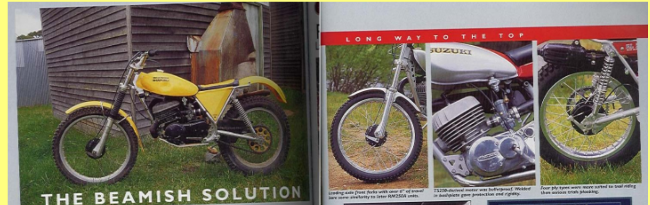
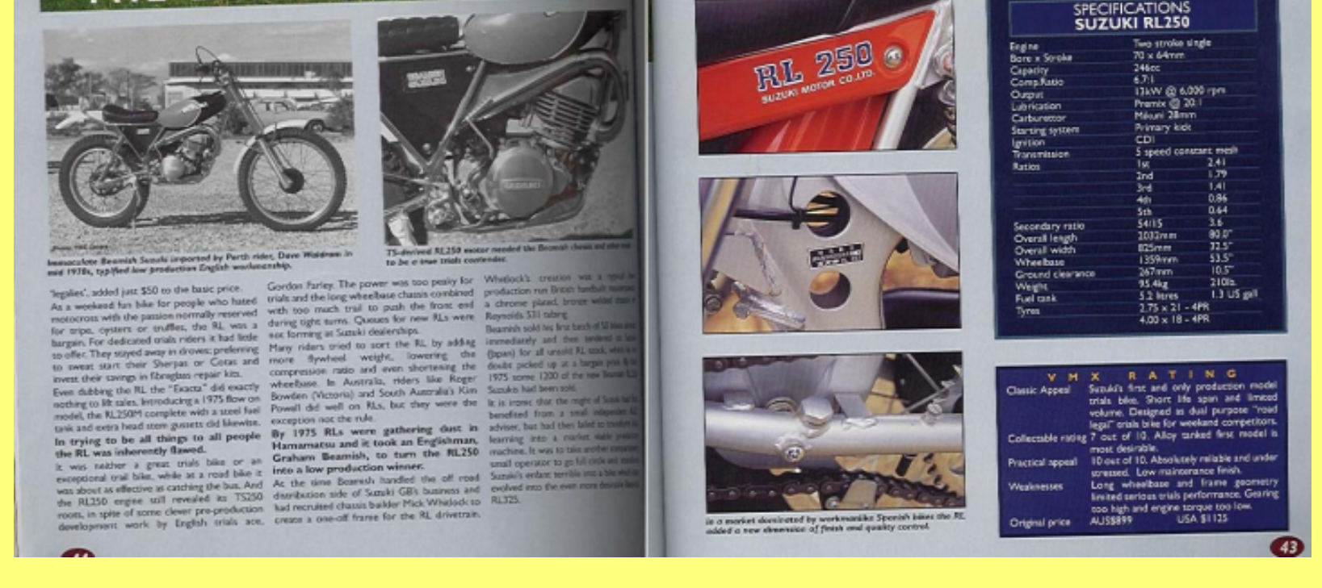

Dating the Silver Engine Beamish
Dating can be done by a combination of the following
- Tank decals
- Frame modification
- Swing arm modifications
- Steel or aluminium tank
- Side panels
- Fork type
- Exhaust
- Side stand
- Engine guard
Even with all of this information it is still a little hit and miss as bikes have been kept running by using any parts that fit!
The very first Beamish had a frame similar looking to that of the old Suzuki Exacta RL250 except that it was chrome plated. They were produced in late 1975 and early 1976. The petrol tanks were steel and painted silver with a wide orange/red stripe down the centre.

Here's what to look for
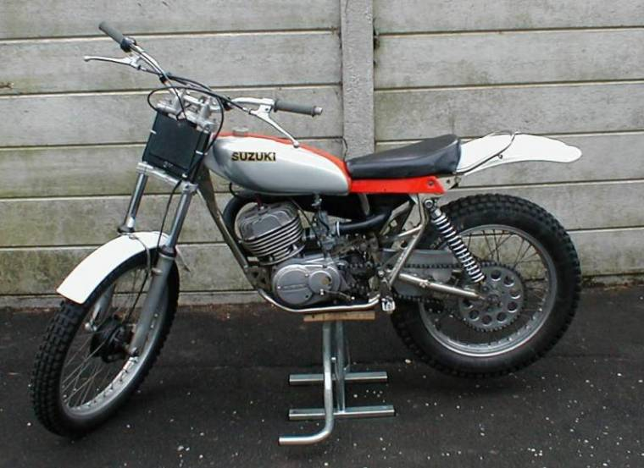
Note the side panels, long and thin. This is a very early example. Don't bother looking for a frame number - they were stuck on and made of Dyno tape - they fell off at the first sign of water! You can't use the engine number to date the bike either I'm afraid. The exhaust was straight from the old Exacta and had a tail section. The swing arm was also straight from the Exacta but now chrome plated.
In 1976 and early 1977 the familiar 'Beamish yellow' appeared. The side panels were triangular and made of aluminium. The tank was still steel.

Dating the Black Engine Beamish
Dating can be done by a combination of the following
- Frame number
- Tank decals
- Frame decals
- Frame modification
- Steel or aluminium tank
Even with all of this information it is still a little hit and miss without the frame number. These bikes were made for trialing and took some serious knocks in their time. If a previous owner replaced a dented aluminium tank with a steel one it can throw you out from your dating process!
I have seen some bikes with a replacement frame which can also put you off the scent.

Here's what to look for

